**CSC2021 Advanced Programming using Android and C++**

**CSC2022 Games Programming using Android and C++**

|  |  |  |
| --- | --- | --- |
| Name | Student Number | QUB Email Address |
| [[Name]] | [[Student#]] | [[Email address]] |
|  |  |  |
|  |  |  |
|  |  |  |
|  |  |  |
|  |  |  |
| Team Number | [[Team number, e.g. gp21]] | |

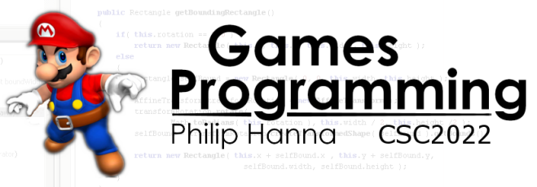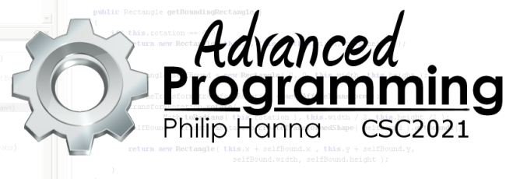

**Sprint**

**Submission**

**Report**

This document provides you with an opportunity to report progress on your game and identify the types of feedback you would like.

**Section 1: Core Information**

Please provide overview information on your team and game.

|  |
| --- |
| Studio Name |
| [[Enter the name of your development studio here]] |

**[Optional] Logo:** If desired, insert your studio’s logo (graphic) below.

|  |
| --- |
| Title |
| [[Enter the title of the game you plan to develop]] |

|  |
| --- |
| Overview |
| [[Provide a brief overview of your proposed game, i.e. genre, aims, play style, etc.]] |

**Section 2: Progress to Date**

Please provide an overview of what you have developed to date. Ensure that your SVN account contains your latest code snapshot.

|  |
| --- |
| Implemented Functionality |
| * [[List implemented functionality here]] |

**Section 3: Feedback**

I will provide you with general feedback on the code that you have submitted to SVN. If there is any specific area/topic you would like feedback on then please indicate this below.

|  |
| --- |
| Specific Areas of Feedback |
| * [[List any specific feedback requests here]] |

**`Section 4: Indicative Progress to Date**

1st

2.1

2.2

3rd

Fail

**Indicative indication of progress**

**Health warning**: The indication of progress here is based on a cursory analysis of what you have submitted to the SVN repository. It does not include an in-depth analysis of your design or code, nor does it contain an analysis of third party code that you have may have used, extended or adapted. Or in short, please consider this a suggestion of how we you appear to be doing at this point in time based on a quick review of your submission.